COMPASS Initial Consultation
Name of Student: _____________________________________________________________________
Name of School: ______________________________________________________________________
Name of Consultant(s): _________________________________________________________________
Date(s) of Consultation: ________________________________________________________________
Attendees
At least one parent/caregiver and special education teacher are required to attend the entire consultation, but all others who interact regularly with the student are encouraged to attend as well. Everyone who participates in the COMPASS consultation needs to complete the following:
Name | Role | Hour per Week with Student
1.
2.
3.
4.
5.
6.
7.
8.
9.
10.
Note:

COMPASS Initial Consultation Guide
The Collaborative Model for Promoting Competence and Success for Persons with Autism Spectrum Disorder (COMPASS) is an evidence-based consultation and coaching intervention designed to help teachers and caregivers collaboratively create and implement an intervention plan designed specifically for students with autism. During this consultation, we will develop the intervention plan together.

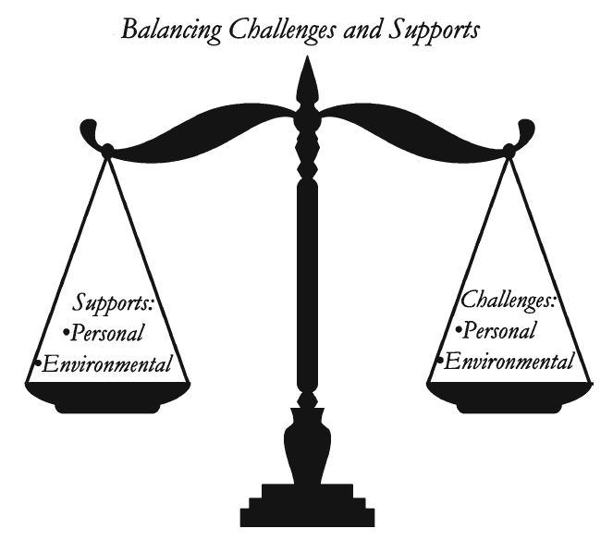
Balancing Challenges and Supports
The goal of COMPASS is to improve child and youth outcomes by balancing personal and environmental challenges (things that make learning difficult) with personal and environmental supports (student interests/strengths and teaching strategies that support learning).

COMPASS does this by bringing together the caregiver and teacher to provide a 360-degree view of the student’s current strengths and needs at school, home, and in the community and providing a process for developing high quality, developmentally appropriate goals and teaching strategies.
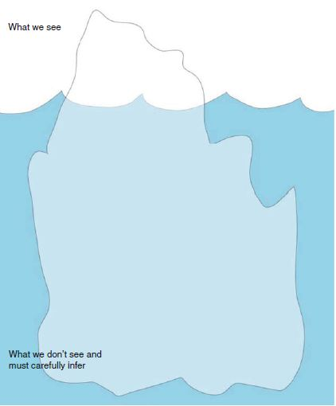
COMPASS focuses on goals in the three areas recommended by the National Research Council (2001) for students with autism: communication skills, social skills, and independent learning skills. These are social emotional learning skills that lay the foundation for successful learning.

Understanding What We See
As we get to know the student, it is important to remember that the root causes for behavior are not always apparent. As we discuss the student, it may be helpful for us to think of the image of an iceberg: what we see is just the tip of the iceberg above the water and what we don’t see are the personal and environmental challenges that we must understand so we can provide support.

Consultation Agenda

- 5 minutes: Make introductions, explain purpose/outcomes of COMPASS
- About 1 hour: Discuss COMPASS Profile. Summarize each section of the profile as you go along and make notes of areas of concern that you may want to focus on for goals later.
- About 30 minutes: Write a communication, social, and independent learning skill goal.
- About 1 ½ hours: After each goal is written, write the step-by-step teaching plans for each goal.
- 5 minutes: Conclude, review, & discuss plans for follow-up coaching.

Writing High Quality Goals
Each goal should contain the following components:
- Condition: In what circumstance do you want to see the behavior?
- Behavior: What is the behavior you want to see?
- Criteria/Frequency: How will you know if goal is achieved?
- Measurement: How will you measure the behavior?
- Timeline: When do you want the skill to be accomplished?
Example: When given a verbal greeting (Hi Matt!), Matt will return the greeting by saying “Hi” independently 4 times per day for five days as measured by a frequency checklist by the end of the school year.
Writing High Quality Teaching Plans
Pre-Teaching Activities
- Is there a skill, activity, or knowledge the student needs to be familiar with prior to implementing the teaching plan (e.g., social story on taking turns)?
- Does the teacher need to review any specific EBPs, set up the environment in a specific way, or get/create specific materials?
- Peer or staff training on teaching sequence
Step-by-Step Teaching Sequence
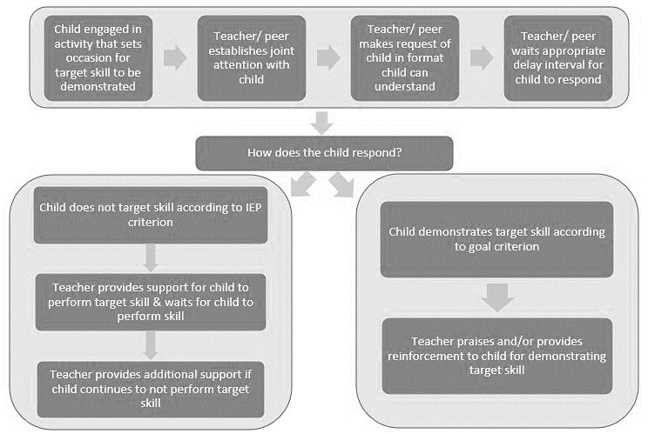
Plans for Maintenance, Self-Direction, and Generalization
Once the student achieves the goal, what are the next steps? How will you maintain the student's performance? How will you help the student become more self-directed and independent? How will you generalize the skill to other situations and environments?

Communication Goal
Personal Challenges | Personal Supports
Environmental Challenges | Environmental Supports
Teaching Plans
Pre-Teaching Activities  Step-By-Step Teaching Sequence  Plans for Maintenance, Self-Direction, and Generalization | Who/ Where/ When
 | Materials
 | Data System
Social Goal
Personal Challenges | Personal Supports
Environmental Challenges | Environmental Supports
Teaching Plans
Pre-Teaching Activities  Step-By-Step Teaching Sequence  Plans for Maintenance, Self-Direction, and Generalization | Who/ Where/ When
 | Materials
 | Data System

Independent Learning Goal
Personal Challenges | Personal Supports
Environmental Challenges | Environmental Supports
Teaching Plans
Pre-Teaching Activities  Step-By-Step Teaching Sequence  Plans for Maintenance, Self-Direction, and Generalization | Who/ Where/ When
 | Materials
 | Data System
COMPASS Caregiver & Teacher Survey

Please rate today’s consultation by circling a number on the line nearest to the description that best fits your experience.

I did not feel heard,  understood, and  respected | 1 2 3 4 5 6 7 8 9 10 | I felt heard, understood, and respected
We did not work on or talk about what I wanted to work on and talk about. | 1 2 3 4 5 6 7 8 9 10 | We worked on and talked about what I wanted to work on and talk about.
The consultant’s approach is not a good fit for me. | 1 2 3 4 5 6 7 8 9 10 | The consultant’s approach is a good fit for me.
There was something missing in the consultation today. | 1 2 3 4 5 6 7 8 9 10 | Overall, today’s consultation was right for me.  Johnson, Miller, & Duncan, 2000

1. What was most helpful about the consultation?

2. What was not helpful?

3. What supports do you need to implement the ideas shared in the consultation?

4. What barriers do you foresee in being able to implement the ideas shared in the consultation?

